Chapter 11, Solution 89.

- Apparent power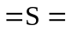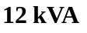

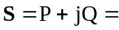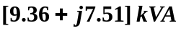

- 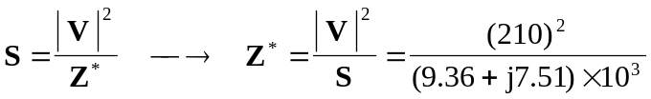 = 2.866 – j2.3

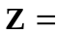 [2.866 + j2.3] Ω

